Term | Definition | Image
Electricity | The flow of electrons. | 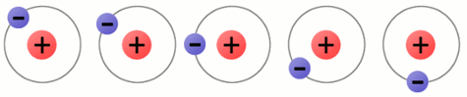
Electron | A tiny particle which rotates around the nucleus of an atom. It has a negative charge of electricity. | 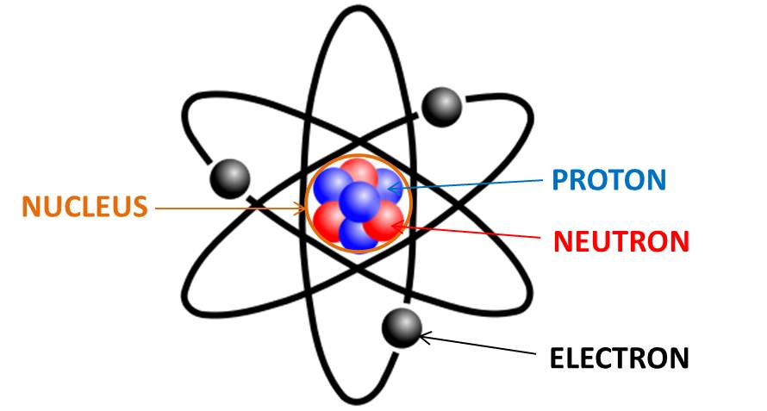  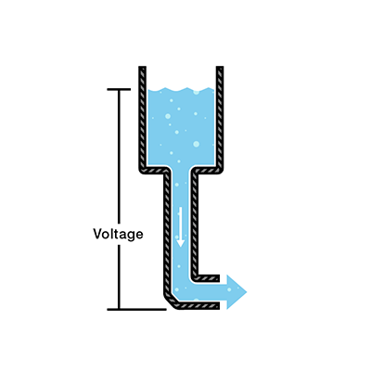
Voltage | An electromotive force or "pressure" that causes electrons to flow and can be compared to water pressure which causes water to flow in a pipe. Measured in volts. | 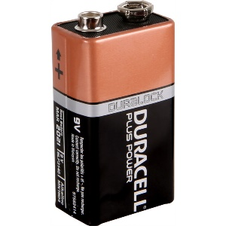
Voltage Source | A two-terminal device which can maintain a fixed voltage - such as a battery or wall outlet. | 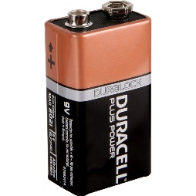  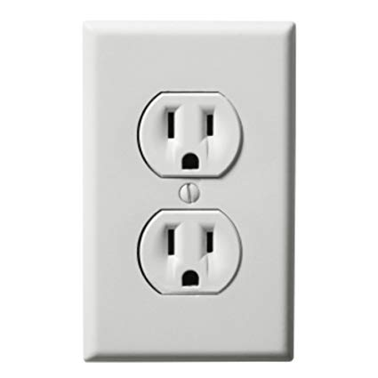
Generator | A device which converts mechanical energy into electrical energy. | 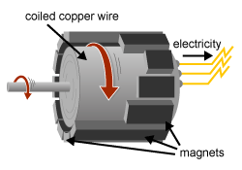
Current | The flow of an electric charge through a conductor - can be compared to the flow of water in a pipe. Measured in amps. | 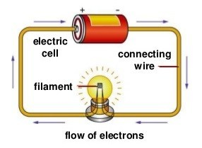
Resistance | The opposition to the passage of an electric current - can be compared to the friction experienced by water when flowing through a pipe. Measured in ohms. | 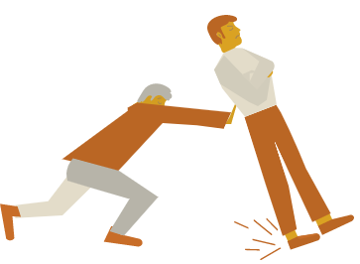
Load | 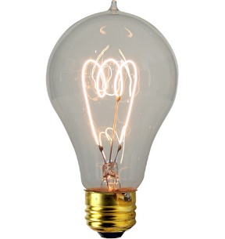  Anything which consumes electrical energy, such as lights, transformers, heaters and electric motors. | 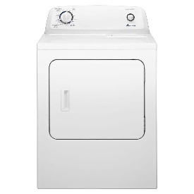  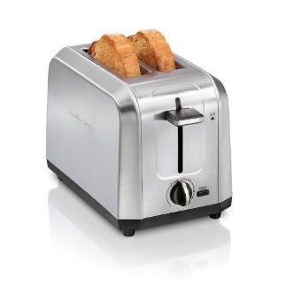
Conductor | Any material where electric current can flow freely, with a relatively low resistance - examples are copper and aluminum wire. | 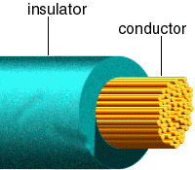
Insulator | Any material where electric current does not flow freely. Materials, such as glass, rubber, air, and many plastics have a relatively high resistance - protect equipment and life from electric shock. | 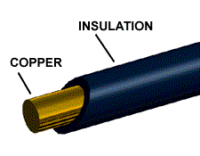
Circuit | 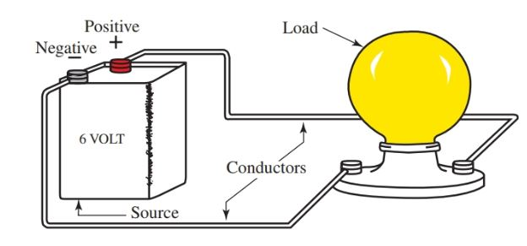  A closed path in which electrons from a voltage or current source flow - can be in series, parallel, or in any combination of the two.
Series Circuit | 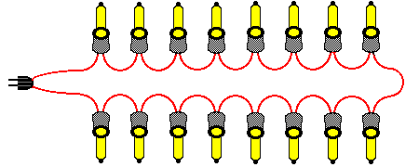  A circuit in which there is only one path for electricity to flow. All of the current in the circuit must flow through all of the loads. Remove one and they all go out!!
Parallel Circuit | A circuit has two or more paths for current to flow through. Remove one and the rest stay on!! | 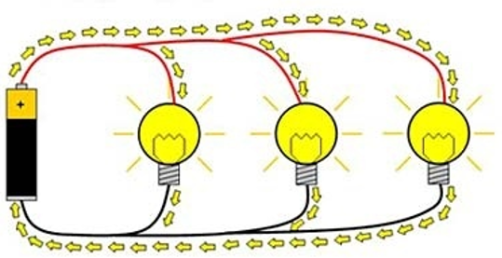
Combination Series-Parallel Circuit | A circuit that has a "combination" of series and parallel paths for the electricity to flow. Most circuits are these. | 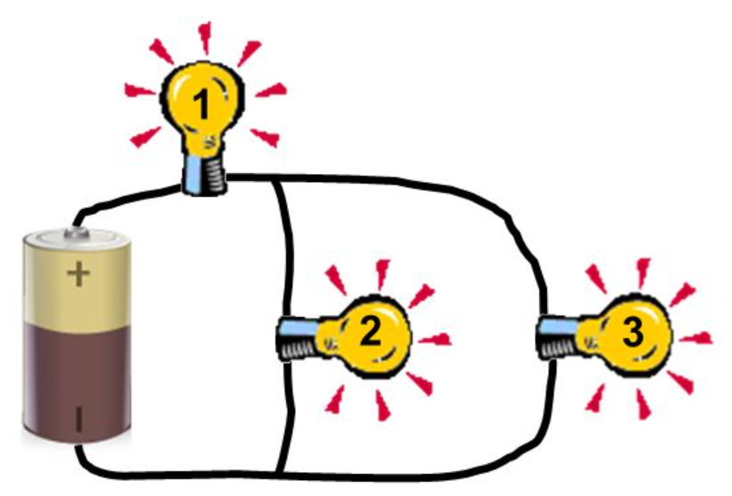
Direct Current (DC) | An electric current that flows in only one direction.  Voltage source: batteries | 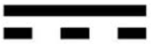
Alternating Current (AC) | An electric current that reverses its direction many times a second at regular intervals.  Voltage source: wall outlet |   